Name: | Class:

①Sort and write the words. Mark / 7
❶ tuan aunt ❺ prgnadsenart ________
❷ gtheruda ________ ❻ nos ________

❸ dggrhnaaduert ________ ❼ lenuc ________

❹ ognrands ________ ❽ stapenr ________

②Look and write. Mark / 8

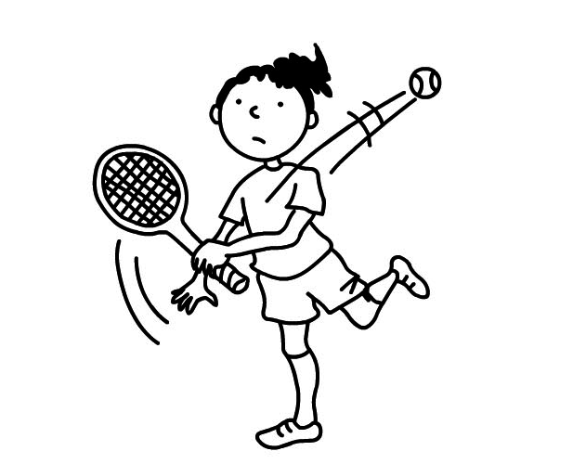
 = like = love  = don’t like

❶ She ‘s playing tennis.
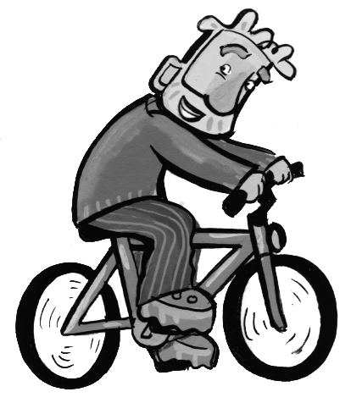
She doesn’t like playing tennis.

❷ He ______________________.
He ______________________.
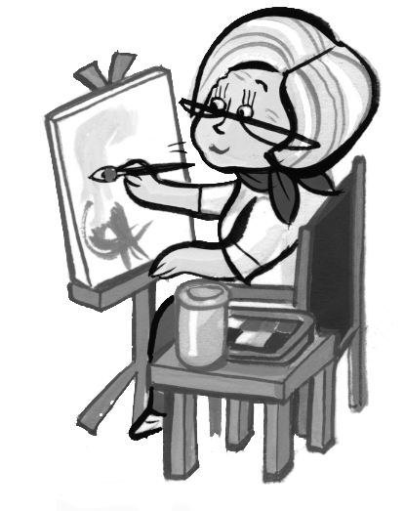
❸ She ______________________.
She ______________________.
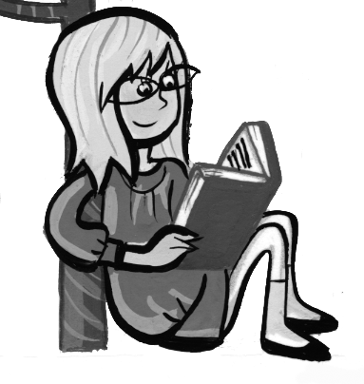
❹ She ______________________.
She ______________________.
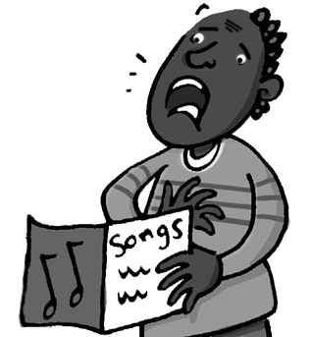
❺ He ______________________.
He ______________________.
Total unit mark / 15

